Oso, Washington Landslide

Executive Summary

Brigham Young University CEEN 544

Noah Taylor and William Garner

April 2015

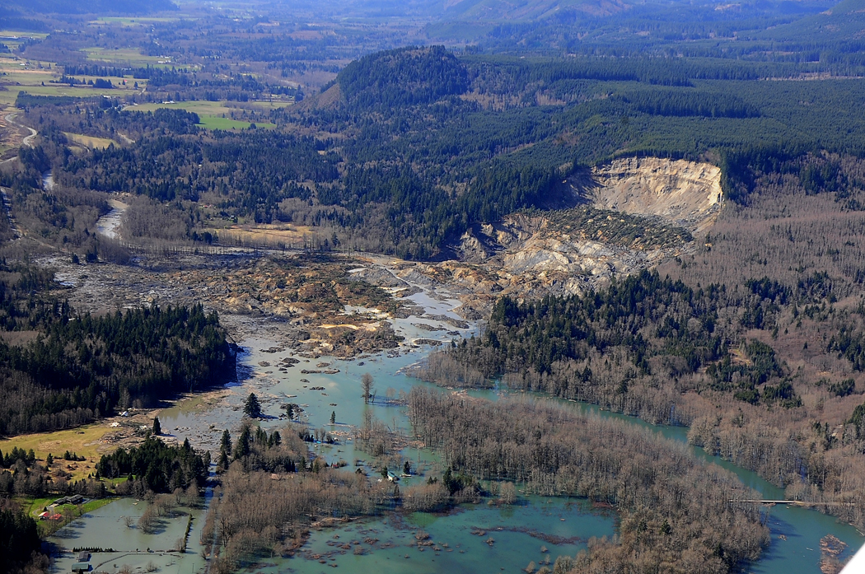

Following several wet months and years On 22 March 2014 a landslide occurred near Oso, Washington. Approximately 8 × 106 m3 of soil were moved. An observer of the slide said he saw “a wall of turbulent earth 100 feet overhead [and] moving 100 miles per hour”. The landslide was extremely mobile and traveled approximately 0.7 miles from the toe of the slope impeding the North Fork Stillaguamish River (USGA 2014). The slide destroyed 0.8 miles of State Route 530 and destroyed 30 homes. Forty three people were killed by the landslide, making this the second most deadly slide disaster in U.S History. (Iverson et al, 2015)

The landslide occurred on a slope 180 meter highs and inclined at an average of less than 20. The slope was made up of Pleistocene glacial till and outwash sediments with a base of glaciolacustrine silt-and-clay. Historically slides have occurred repeatedly in this same area. One notable slide was the 2006 Hazel ot Steelhead slide (Iverson et al, 2015). The Oso slide was unique because the slide exhibited a large degree of mobility. Although the slide occurred on a sunny, dry day, it followed an unusually high period of precipitation period. Meteorologic data shows precipitation to be between 150 to 200% above the long term average (USGS 2014). This likely contribute to higher than average pore pressures.

Four days were spent by a GEER reconnaissance collecting data. Observational data was used to determine evidence of rotation, extensions, localized compression, discrete head scarp failures, post-failure, debris flow, and liquefaction. A hand auger was used to collect soil sample and these samples were then tested in the lab for atterberg limits, moisture content, gradation, strength, permeability parameters (Keaton et al, 2014). Data from 18 broadband seismic stations provided chronological data and lidar data from before and after was used to map movement and other spatial data. Eye witness statements were also used as data.

After the events, a number of different analysis were performed to better understand the mobility and dynamics of the Oso landslide. A quick look at the outcome of the landslide suggest it fell into the category of rotational landslide failure type. The analysis that the USGS were involved with include a GIS and lidar analysis that was performed to better estimate the volume and extents of the landslide. This was accomplished by performing a data analysis contrasting the pre and post high resolution digital elevation maps of the area. The volume was estimated to have been 8 × 106 m3. A seismological analysis was also performed through regional earthquake sensors that were able to record the disturbances through the subsurface. This analysis was used to interpret approximately how long the landslide took place.

Lastly, a numerical analysis was performed on the basis of the volume and time derived from the previous two analysis. The numerical model is useful as it allows for the interpretation of material properties based on the constraints of time and volume. The results of the calibrated numerical model determined that the initial sediment porosity was 0.38. The basal friction angle was 36 degrees. For complete results, see Iverson, 2014

References:

Iverson R.M et al. (2014). Landslide mobility and hazards: implications of the 2013 Oso Disaster. Earth and Planetary Science Letters 412 (2015) 197-208, Elsevier B.V. <http://www.sciencedirect.com/science/article/pii/S0012821X1400781X>

Keaton Jeffery R. et al, (2014) Geotechnical Extreme Events Reconnaissance Turning Disaster into Knowledge. National Science Foundation.

United State Geological Survey. (2014). Landslide in Washington State. Retrieved from <http://www.usgs.gov/blogs/features/usgs_top_story/landslide-in-washington-state/>. March 2014.